**CSS Task Day-1**

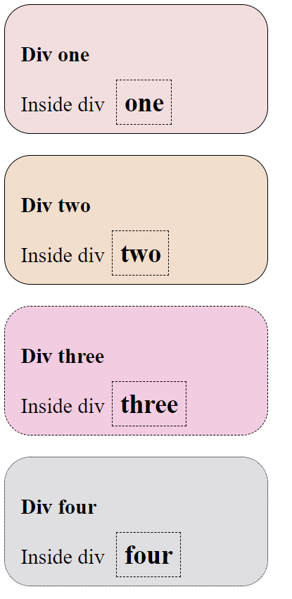

Hint: use combinators in styling each box and each box title(Dive one, Dive two,…) and the (Inside div) sentence.

**DO NOT USE ANY INLINE OR INTERNAL STYLING**